**EverSure Business Process Management Project**

**Merging Traditional and Digital Insurance Processes**



**Course:** BUS 353: Business Process Management

**Project Date:** April 7, 2025

**Team Members:**

* Vibhu (Student ID): 300195285
* Arnav (Student ID: 300206166
* Archie (Student ID: 300206303
* Isha (Student ID: 300207023
* Richa (Student ID: 300190757
* Sahaj (Student ID: 300200340

**Table of Contents**

1. Executive Summary
2. Introduction
3. As-Is Process Discovery and BPMN Models
   * Traditional Process
   * Digital Process
4. As-Is Process Analysis
   * Cycle Time Efficiency
   * Issue Register
5. Process Redesign Proposal
   * Change 1: Unified Information System
   * Change 2: Hybrid Lead Qualification System
   * Change 3: Streamlined Reporting and Offer Preparation
   * Change 4: Integrated Contract and Payment Processing
6. Expected Benefits
7. Conclusion
8. References

**1. Executive Summary**

EverSure, a legacy insurance provider with more than 20 years in the industry, has recently acquired a digital competitor in response to evolving market trends. This project evaluates EverSure's dual process landscape—traditional and digital—for selling insurance products and aims to merge them into a unified process that enhances operational efficiency, reduces redundancy, and delivers improved customer experience.

Through detailed process discovery, BPMN modeling, cycle time efficiency analysis, and identification of key bottlenecks, our team has proposed four targeted changes. These include implementing a unified IT system, redesigning lead management, automating reporting, and integrating contract/payment processes.

Our proposed improvements promise increased efficiency, lower costs, and a strategic alignment of operations with modern customer expectations.

**2. Introduction**

EverSure has operated with deep knowledge of customer needs, maintaining a traditional, relationship-driven business model. Recently, the company acquired a digital insurance provider to strengthen its competitiveness. However, this acquisition introduced operational complexities, as two different processes, systems, and work cultures now co-exist within the organization.

This project:

* Documents and models both traditional and digital processes using BPMN.
* Analyzes each process for inefficiencies and structural gaps.
* Identifies key issues causing delays, errors, and opportunity losses.
* Proposes integrated redesigns aligned with Business Process Redesign (BPR) principles.

**3. As-Is Process Discovery and BPMN Models**

**3.1 Traditional Process**

**Overview:**

* Sales representatives identify leads manually.
* Admins prepare a detailed customer report from CNTR.
* Meetings are scheduled, offers are customized, and client responses are awaited.
* Contracts are processed via CNTR and registered into OPER

.

**Key Attributes:**

* Processing Time: ~21–24 hours
* Waiting Time: ~216–312 hours
* Success Rate: 60% interest post-meeting, 50% acceptance
* Contract Value: ~20,000€
* Monthly Leads: ~100

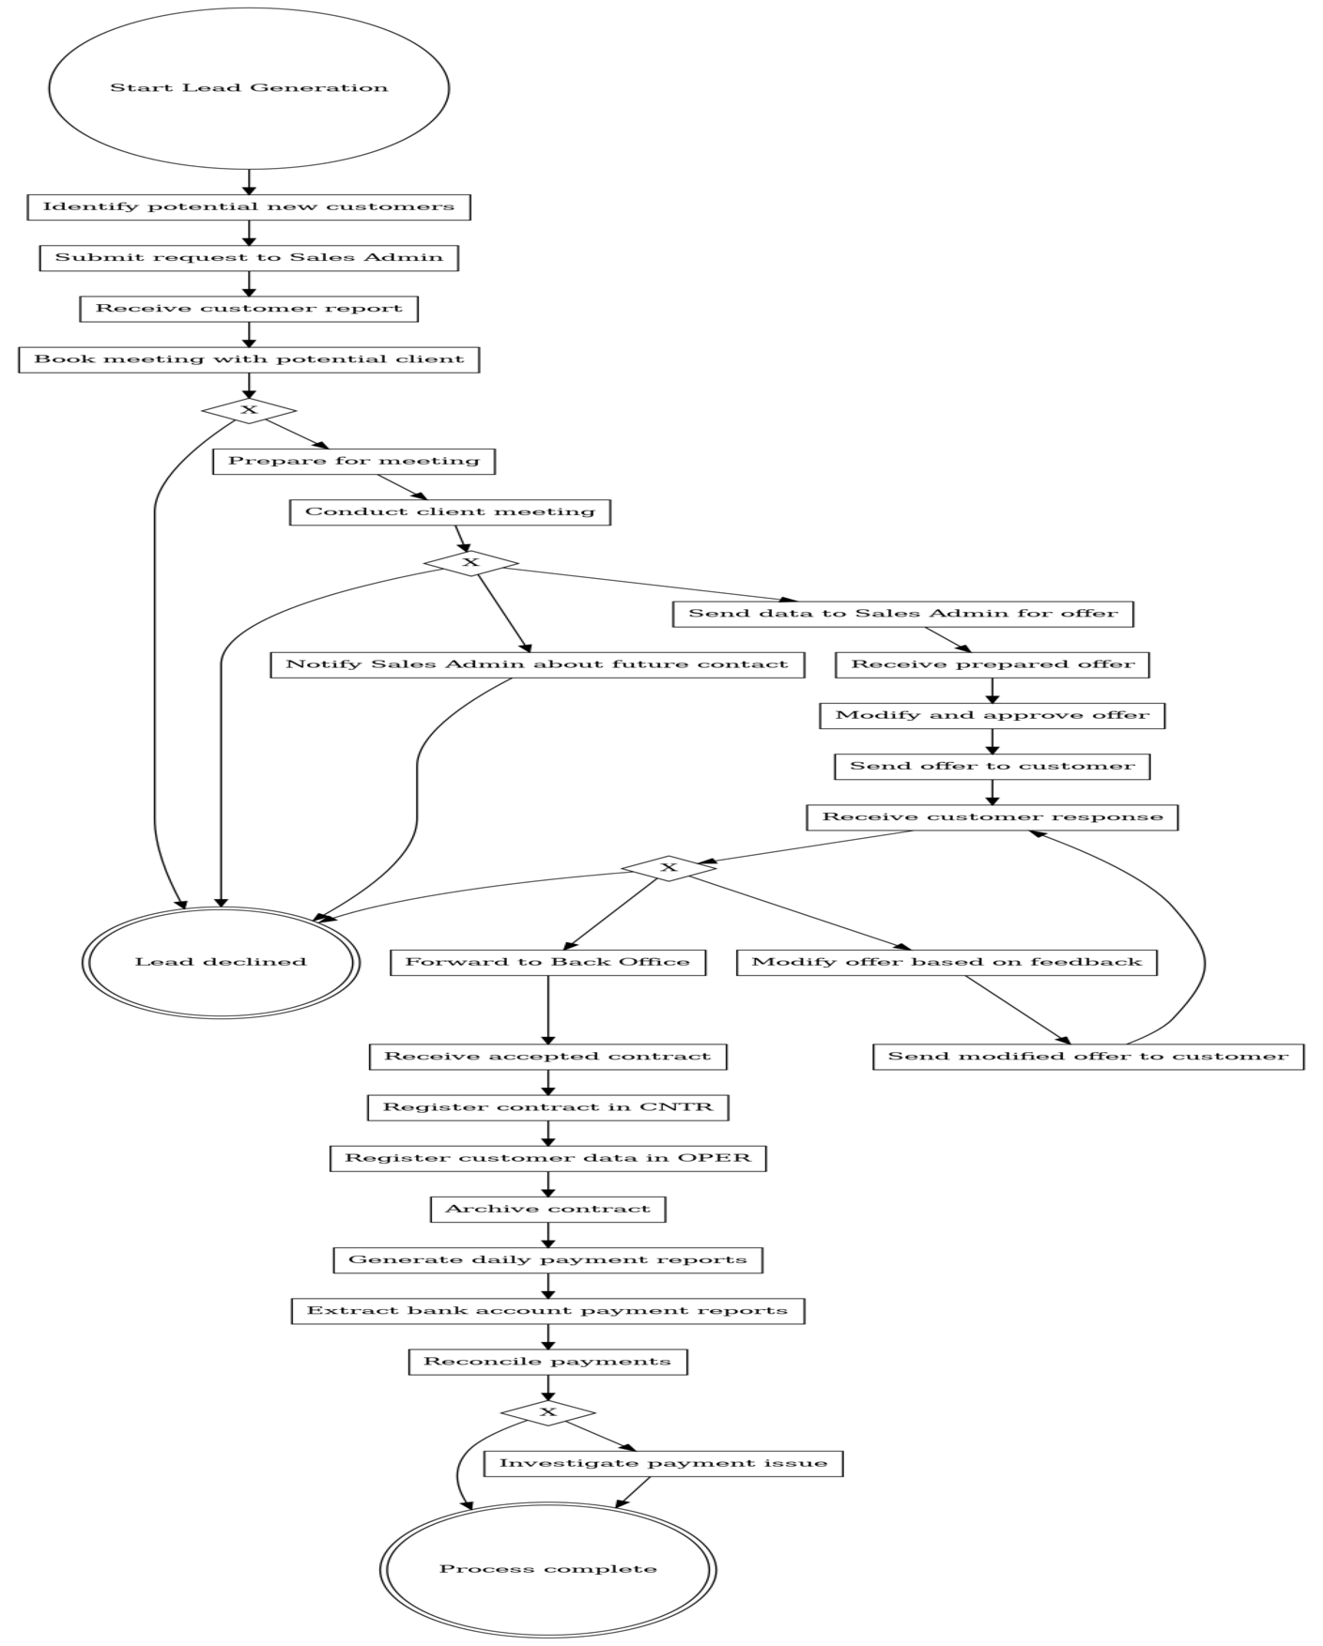**BPMN Diagram:**

**3.2 Digital Process**

**Overview:**

* Marketing team generates leads via ads and content.
* An algorithm filters leads; sales sends standard offers.
* 70% non-response rate after 3 weeks.
* Contracts are processed in INSU and registered in AUIN.

**Key Attributes:**

* Processing Time: ~10.27–14.27 hours
* Waiting Time: ~152–168 hours
* Conversion Rate: ~10%
* Contract Value: ~500€
* Monthly Leads: ~1,000

**BPMN Diagram:**

**4. As-Is Process Analysis**

**4.1 Cycle Time Efficiency**

**Formula Used:**  
CTE = Processing Time / (Processing Time + Waiting Time)

**Traditional Process:**

* Best Case: 21 / (21 + 216) = **8.86%**
* With Modifications: 24 / (24 + 312) = **7.14%**

**Digital Process:**

* Best Case: 10.27 / 162.27 = **6.33%**
* With verify Request: 14.27 / 182.27 = **7.83%**

**Assumptions:**

* 40-hour working week
* Sequential execution (no parallelism)
* Waiting time = 0 when unspecified
* Reasonable estimates were made where processing times were not given

**4.2 Issue Register**

|  |  |  |  |  |
| --- | --- | --- | --- | --- |
| **Issue** | **Description** | **Impact** | **Evidence** | **Assumptions** |
| **1. Disconnected IT Systems** | CNTR/OPER vs. INSU/AUIN; redundant data entry, inconsistent visibility | 15% error rate in digital; missed cross-selling; duplicate data | 4 different systems, no integration | 20,000€ savings with unified system |
| **2. Excessive Waiting in Traditional Process** | Delays in reporting and meetings | Low CTE (8.5%), opportunity loss (20%) | 1-week report wait, 2-week meeting delay | Faster reporting won’t lower quality |
| **3. Poor Digital Lead Quality** | 70% no response; 10% contract conversion | Wasted marketing spend, low ROI | 50% filtered, 70% ignored | Algorithm lacks precision |

**5. Process Redesign Proposal**

**Change 1: Unified Information System**

* **Add**: One platform replacing CNTR, OPER, INSU, AUIN
* **Drop**: Redundant data entry and separate platforms
* **Benefits**: Lower error rate (from 15% to 5%), 10% faster back-office work, 20,000€ annual savings
* **BPR Principles**: Technology enablement, Integration, Error prevention

**Change 2: Hybrid Lead Qualification System**

* **Add**: Lead scoring algorithm combining sales insights
* **Drop**: Separate lead gen processes
* **Benefits**: Better targeting; 20% more good leads; lower non-response (below 50%)
* **BPR Principles**: Task elimination, Triage, Empowerment

**Change 3: Automated Reports & Offers**

* **Add**: Pre-filled report and offer templates
* **Drop**: Manual customer reports and handoffs
* **Benefits**: Report wait reduced from 1 week to zero; 20% more clients reached
* **BPR Principles**: Automation, Case Manager, Resequencing

**Change 4: Integrated Contract & Payment Processing**

* **Add**: Standard templates; cross-channel workflow
* **Drop**: Separate contract flow per channel
* **Benefits**: 10% faster processing; unified back office; lower error and investigation time
* **BPR Principles**: Case-based work, Integration, Exception handling

**6. Expected Benefits**

**Efficiency**

* CTE improved to 15%
* Back office 10% faster
* Reporting and payment delays reduced

**Cost Savings**

* 20,000€ IT savings/year
* Lower error rates reduce rework
* Streamlined onboarding and training

**Growth**

* 20% more traditional customers
* 20% better lead quality (digital)
* Higher conversion rates

**Customer Experience**

* Faster responses
* Consistent service
* Personalized offerings
* Fewer delays or errors in processing

**7. Conclusion**

EverSure’s dual-channel setup revealed both opportunities and inefficiencies. The traditional process offers depth and relationship-building but suffers from time lags. The digital process brings speed and scale but lacks precision in targeting.

By redesigning around four core changes—system unification, hybrid lead scoring, automation of reporting, and centralized contract management—EverSure can build a merged, efficient, and scalable future-ready business process.

This new model positions the company for sustained growth, better service, and stronger competitive advantage.

**8. References**

* EverSure Case Study (2025)
* BPMN Modeling Guidelines – BPMN.io
* BUS 353 Lecture Notes – University LMS
* Milani, F. (2020). Business Process Management Frameworks